**Bookstore Data Analysis Using Power Bi**

**Data Source :**

The Bookstore data consists of following tables:

* Books : It contains the information about the book title, author, categories, prices, stock quantity and published date.
* Customer : Holds the customers details such as name, contact info, age, nationality.
* Order details : It track transactions, including sales date, customer_id, book_id and quantity sold.

**Data Processing and ETL Process :**

Extract the raw data from the database by join query

select od.*, b.title, b.categories, b.published_date, b.price, b.stock_quantity, a.full_name, a.nationality, c.customer_name, c.city, c.state, c.zip_code, c.country from order_details as od

full join books as b

on b.book_id = od.book_id

full join authors as a

on a.author_id = od.author_id

full join customers as c

on c.customer_id = od.customer_id

**Transform the Data :**

During the transformation stage, the following tasks were performed:

Data Cleaning: Removes the duplicates values, null values, handled the missing values and set the correct datatype of each columns.

Data Normalization: Normalized the data to 3rd Normal Form (3NF) by breaking down the larger table into smaller ones and ensure the data dependencies are logical.

I separated the **books** and **authors** table into distinct tables to avoid data redundancy. **Order data** was linked to both the **customer** and **books** table through foreign keys. Also we break the **customer table** into **customer location** and **age category** and both linked through foreign keys to the customer table.

The clean and normalized data was loaded into power BI for further analysis and visualizations.

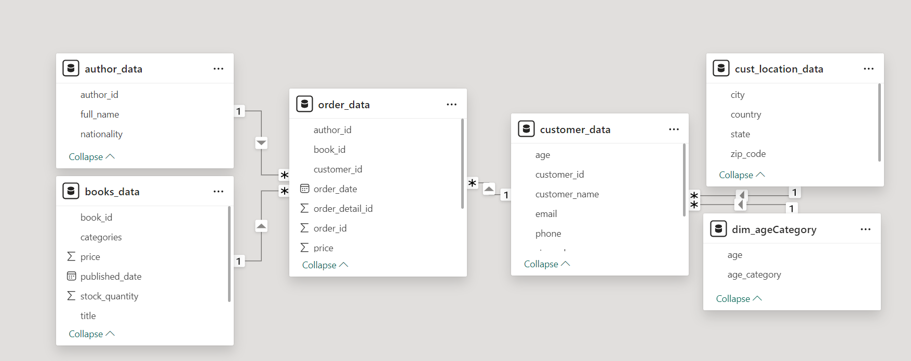

The structure of the Bookstore Data and it shows the relationship between the each others.

**Visualization and Dashboard :**

After building the data model, the following visualizations was created to give insights into bookstore data.

**Filters :**

**Country Slicer :** Slicer at the top allows user to filter the data by country. User can select multiple countries from the list, to analyze sales performance or book data by specific region.

**Categories Slicer :** This Slicer allows the user to filter the data by categories of books.

**Years Slicer :** This Slicer allows user to filter the data by years to analyse the sales, orders details etc.

**Visuals :**

**Bar and Line chart :** The x-axis shows different book categories.

Total Amount: Represented by the bars, each category has total amount in sales.

Stock Quantity: The line plot superimposed on the bars represents the quantity of books in stock (on the right y-axis).

**Pie Chart :** It shows the sum of total amount and count of title by book categories . Each segment of the pie chart represents a book category

**KPI Card :**

Total Sales: Displays the sum of all sales across the filtered data, showing a total of 62.30K.

Average Customer: Shows the average sales amount per customer, displayed as 935.08.

Order Years : It shows the total orders in a year across the filtered , it displayed a total 11k orders.

**Line Chart :** It shows the sum of price and First city by book categories.

**Treemap visualizes :** The total sales amount broken down by book categories and the first country where those sales occurred.

The size of the blocks represents the magnitude of the total amount for each category.

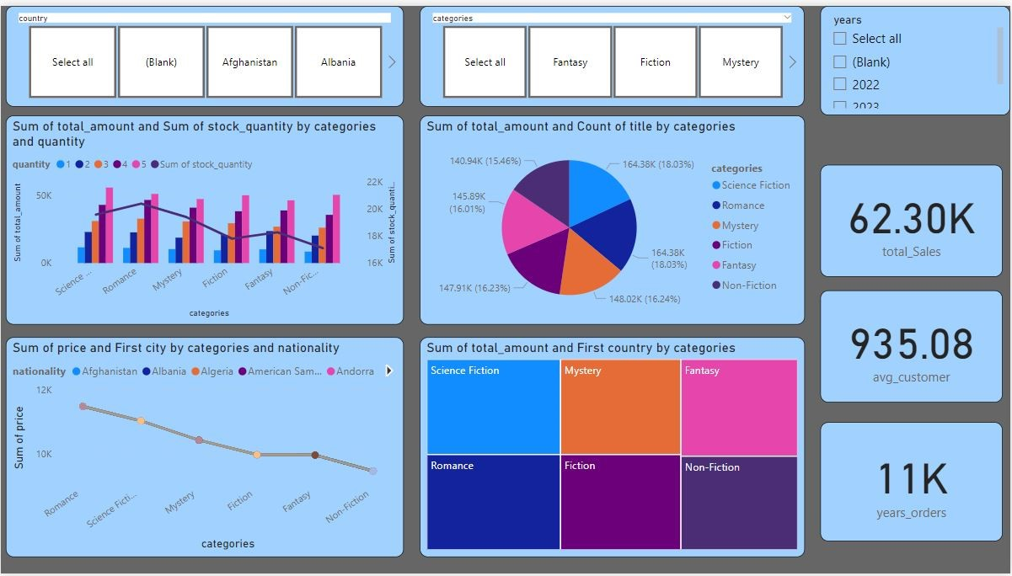**Dashboard of Bookstore Data :**